Generic ERP Integration Solution – AWS Native Architecture

Executive Summary
The proposed Generic ERP Integration Solution is a modern, cloud-native integration platform built entirely on Amazon Web Services (AWS). The platform is designed to replace legacy Windows server-based schedulers, desktop services, and tightly coupled ERP integrations with a scalable, secure, highly available, and operationally efficient architecture.
The solution enables automated and manual invoice posting, feed downloads, document processing, image handling, retry management, monitoring, and audit tracking for multiple ERP systems and client-specific integrations.
The architecture is designed around reusable components, centralized orchestration, client-specific plugins, and serverless execution models to support both current and future ERP integrations with minimal infrastructure overhead.
The platform follows AWS Well-Architected best practices across:
- Security
- Reliability
- Operational Excellence
- Performance Efficiency
- Cost Optimization
- Scalability
The solution is fully Infrastructure-as-Code (IaC) driven, CI/CD enabled, and supports multi-client onboarding through configuration-driven execution.
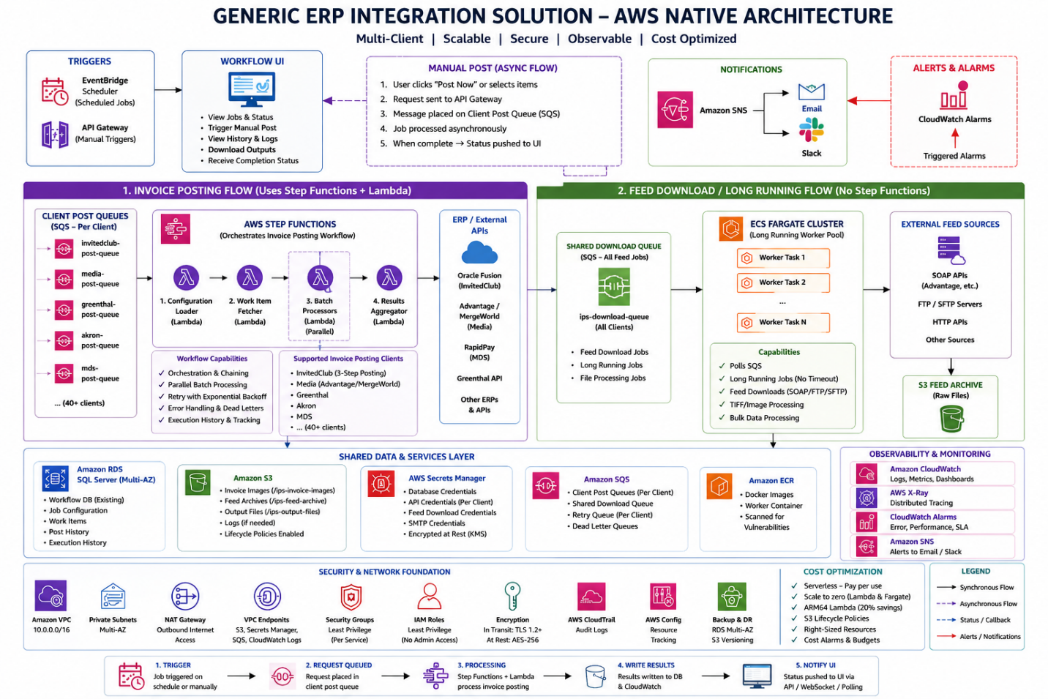

1. Solution Objectives
The Generic ERP Integration Solution is intended to achieve the following objectives:
- Modernize legacy integration processes currently dependent on Windows services and on-premise infrastructure
- Provide a reusable framework for integrating multiple ERP platforms
- Reduce operational dependency on always-on servers
- Improve scalability for high-volume invoice and feed processing
- Enable secure handling of credentials and sensitive business data
- Centralize logging, monitoring, alerting, and operational visibility
- Support both scheduled and manual execution models
- Minimize infrastructure cost using pay-per-use AWS services
- Provide fault isolation and retry capabilities
- Standardize deployment and operational processes across all integrations

2. Solution Overview
The architecture is designed as a hybrid execution platform using:
- AWS Lambda for serverless processing
- AWS Step Functions for workflow orchestration
- Amazon ECS Fargate for long-running workloads
- Amazon EventBridge Scheduler for job scheduling
- Amazon SQS for asynchronous queue-based processing
- Amazon RDS SQL Server for transactional data storage
- Amazon S3 for file and image storage
- AWS Secrets Manager for secure credential management
- Amazon CloudWatch and X-Ray for observability and tracing
The platform supports:
- Invoice posting integrations
- Feed download integrations
- ERP synchronization
- Image/document handling
- Retry workflows
- Batch processing
- Manual operational triggers
- Audit and execution history tracking

3. Architectural Design Principles
The platform is designed around the following principles:

3.1 AWS Native First
The solution prioritizes managed AWS services over self-managed infrastructure to reduce operational overhead and improve reliability.

3.2 Serverless by Default
Invoice posting and orchestration workloads use serverless execution wherever possible to minimize idle infrastructure costs.

3.3 Configuration-Driven Execution
Schedules, routing logic, authentication settings, and client-specific behavior are configuration-based rather than hardcoded.

3.4 Plugin-Based Integration Model
Each ERP/client integration is implemented as a reusable plugin while leveraging a shared orchestration and execution framework.

3.5 Fault Isolation
Failures in one client integration do not impact other clients or workflows.

3.6 Scale-on-Demand
The platform automatically scales based on workload volume and queue depth.

3.7 Security by Design
All credentials, network access, and resource permissions follow least-privilege principles and encrypted communication.

4. Core AWS Services Used

4.1 Amazon EventBridge Scheduler
EventBridge Scheduler acts as the centralized scheduling engine for all automated integration jobs.
Responsibilities:
- Trigger scheduled invoice posting
- Trigger feed downloads
- Support cron-based and interval-based execution
- Support timezone-aware scheduling
- Eliminate dependency on Windows Task Scheduler
Benefits:
- Fully managed scheduling
- Zero infrastructure management
- High reliability
- Very low operational cost
- Per-client scheduling flexibility

4.2 AWS Lambda
AWS Lambda hosts the serverless processing components for invoice posting and orchestration.
Responsibilities:
- Configuration loading
- Work item retrieval
- Batch execution
- Result aggregation
- Retry processing
- Manual trigger handling
Benefits:
- Pay-per-use execution model
- Automatic scaling
- No server management
- Fast deployment cycles
- Reduced operational overhead

4.3 AWS Step Functions
Step Functions provides workflow orchestration for invoice posting processes.
Responsibilities:
- Coordinate Lambda execution flow
- Execute parallel batch processing
- Handle retries and failure scenarios
- Maintain execution state
- Provide workflow visibility
Benefits:
- Visual workflow management
- Built-in retry handling
- Improved operational visibility
- Simplified orchestration logic
- Fault-tolerant processing

4.4 Amazon ECS Fargate
ECS Fargate is used for workloads that exceed Lambda runtime limitations or require specialized runtime dependencies.
Responsibilities:
- Long-running feed downloads
- Large file processing
- TIFF/image processing
- Extended ERP synchronization jobs
Benefits:
- No server management
- Scale-to-zero architecture
- Support for long-running processes
- Containerized deployment model
- Efficient compute scaling

4.5 Amazon SQS
Amazon SQS provides asynchronous decoupling between services.
Responsibilities:
- Queue-based workload distribution
- Dedicated posting queue per client/integration
- Retry handling
- Dead-letter processing
- Long-running job orchestration
- Manual posting request processing
- Background asynchronous execution
Dedicated Queue Architecture:
Each ERP/client integration has its own isolated SQS queue.
Examples:
- ips-post-invitedclub-queue
- ips-post-media-queue
- ips-post-greenthal-queue
- ips-post-mds-queue
Each queue also has a dedicated Dead Letter Queue (DLQ).
Benefits of dedicated client queues:
- Complete client isolation
- Independent retry handling
- No cross-client processing impact
- Better operational visibility
- Easier troubleshooting
- Client-level scaling control
- Independent SLA management
- Simplified cost attribution
Benefits:
- Reliable message delivery
- Automatic retry support
- Failure isolation
- Improved scalability
- Backpressure handling
- Asynchronous processing support
- Improved UI responsiveness

4.6 Amazon API Gateway
API Gateway exposes secure APIs for manual operational actions.
Responsibilities:
- Manual invoice posting
- Feed refresh requests
- Operational API endpoints
- API authentication and throttling
Benefits:
- Secure HTTPS endpoints
- API key support
- Rate limiting
- Centralized API management

4.7 Amazon S3
Amazon S3 provides centralized cloud storage for integration artifacts.
Responsibilities:
- Invoice image storage
- Feed archive storage
- Generated output files
- Document retention
Benefits:
- Highly durable storage
- Lifecycle management
- Shared access across services
- Low storage cost
- Scalable file management

4.8 AWS Secrets Manager
Secrets Manager securely stores and manages credentials.
Responsibilities:
- Database credentials
- ERP API credentials
- SMTP credentials
- Feed authentication secrets
Benefits:
- Encrypted secret storage
- Runtime secret retrieval
- Auditability
- IAM-based access control
- Elimination of credentials in source code

4.9 Amazon CloudWatch
CloudWatch provides centralized monitoring, logging, metrics, and alerting.
Responsibilities:
- Centralized application logs
- Operational dashboards
- Execution metrics
- Alert generation
- Performance monitoring
Benefits:
- Centralized observability
- Real-time operational visibility
- Searchable logs
- Automated alerting
- Simplified troubleshooting

4.10 AWS X-Ray
X-Ray provides distributed tracing and performance analysis.
Responsibilities:
- Request tracing
- Dependency analysis
- Performance bottleneck identification
- Execution latency analysis
Benefits:
- Faster troubleshooting
- Improved performance visibility
- Root-cause analysis
- End-to-end tracing

5. High-Level Execution Flow

Scheduled Processing Flow
- EventBridge Scheduler triggers execution based on configured schedule.
- AWS Step Functions initiates workflow orchestration.
- Lambda loads configuration and retrieves credentials.
- Pending work items are retrieved from RDS.
- Processing batches are generated.
- ERP-specific plugins execute posting logic.
- Results are aggregated and persisted.
- Metrics and logs are published to CloudWatch.
- Failures are retried or routed to dead-letter queues.
- Notifications are generated when required.

Manual Processing Flow
The manual posting architecture is designed as a fully asynchronous workflow to improve UI responsiveness, scalability, and operational reliability.
- User initiates manual execution from the Workflow UI.
- API Gateway validates the request and forwards it to the orchestration layer.
- A message containing JobId, ClientType, UserContext, and selected WorkItemIds is published to a dedicated client-specific SQS queue.
- The UI immediately receives an acknowledgment response with tracking information instead of waiting for processing to complete.
- AWS Step Functions and Lambda workers consume the message asynchronously.
- Invoice posting and ERP integration processing execute in the background.
- Execution status, logs, and progress updates are persisted to the database.
- Once processing completes, completion status and results are pushed back to the Workflow UI through notification APIs, WebSocket mechanisms, or polling endpoints.
- Users can monitor execution progress and retrieve final processing results directly from the UI.
Benefits of the asynchronous manual processing model:
- Prevents long-running UI requests and browser timeouts
- Improves user experience and responsiveness
- Supports large-volume manual posting requests
- Enables reliable retry and recovery mechanisms
- Decouples UI operations from backend processing
- Improves scalability during peak operational periods

Long-Running Processing Flow
- EventBridge publishes execution message to SQS.
- ECS Fargate auto-scales based on queue depth.
- Worker containers process long-running jobs.
- Output files and archives are stored in S3.
- Execution results are logged and monitored.

6. Security Architecture
The solution follows enterprise-grade AWS security practices.

6.1 IAM Least Privilege Model
Every AWS service receives a dedicated IAM role with only the permissions required for execution.
Key principles:
- No shared admin credentials
- Service-specific IAM roles
- Restricted resource access
- Principle of least privilege

6.2 Network Security
The platform is deployed inside a private AWS VPC.
Security controls include:
- Private subnets for compute workloads
- Security-group-based firewall rules
- Restricted database access
- NAT Gateway for controlled outbound traffic
- VPC Endpoints for private AWS service communication

6.3 Encryption
Encryption is enabled across all critical components.
Protected resources include:
- RDS databases
- S3 buckets
- SQS queues
- Secrets Manager secrets
- Network communication
- Lambda environment variables
All communication uses TLS 1.2+.

6.4 Secure Credential Handling
No credentials are stored in source code or configuration files.
Credentials are:
- Retrieved dynamically at runtime
- Encrypted at rest
- Access-controlled through IAM
- Audited through AWS logging services

7. Scalability and Reliability
The architecture is designed for horizontal scalability and high availability.

Scalability Features
- Lambda automatic concurrency scaling
- Parallel batch processing through Step Functions
- Queue-driven ECS scaling
- Stateless execution model
- Multi-client parallel processing

Reliability Features
- Multi-AZ deployment model
- Automatic retries
- Dead-letter queues
- Fault isolation
- Durable queue-based processing
- Centralized monitoring and alerting

8. Observability and Operations
The platform provides centralized operational visibility.

Logging
- Structured centralized logs in CloudWatch
- Client-specific log segregation
- Searchable operational history
- Retention management

Metrics
- Success/failure tracking
- Execution duration tracking
- Queue depth monitoring
- Lambda performance metrics

Alerts
Automated alerts are generated for:
- High failure rates
- Lambda timeouts
- Queue backlogs
- Database performance issues
- Feed processing failures

Dashboards
Centralized operational dashboards provide:
- Real-time execution visibility
- Performance trends
- Client-level monitoring
- Infrastructure health metrics

9. Cost Optimization Strategy
The architecture is optimized to minimize infrastructure cost.

Key Cost Optimizations
- Serverless execution for intermittent workloads
- Scale-to-zero compute architecture
- Managed AWS services
- Queue-driven scaling
- Pay-per-use execution model
- Storage lifecycle policies

Financial Benefits
Compared to traditional always-on infrastructure:
- Reduced idle compute cost
- Reduced operational overhead
- Reduced infrastructure maintenance
- Improved resource utilization
- Predictable scaling behavior
The estimated operational cost for the proposed architecture is significantly lower than maintaining dedicated always-on Windows servers for all workloads.

10. Deployment and DevOps Strategy
The platform supports modern DevOps and CI/CD practices.

CI/CD Pipeline
Automated deployment pipeline includes:
- Source control integration
- Automated builds
- Automated testing
- Infrastructure deployment
- Application deployment
- Smoke testing
- Rollback support

Infrastructure as Code
All infrastructure is deployed using AWS CloudFormation.
Benefits:
- Repeatable deployments
- Environment consistency
- Automated provisioning
- Simplified disaster recovery
- Version-controlled infrastructure

Deployment Strategy
The platform supports:
- Blue/green deployments
- Zero-downtime releases
- Controlled traffic shifting
- Instant rollback capability

11. Benefits of the Proposed AWS Native Architecture

Operational Benefits
- Reduced server management
- Improved monitoring and visibility
- Centralized logging and alerting
- Simplified deployment processes
- Faster troubleshooting

Technical Benefits
- Highly scalable architecture
- Modular plugin-based integration model
- Fault-tolerant processing
- Improved resiliency
- Simplified onboarding of new ERP integrations

Security Benefits
- Secure credential management
- Private network architecture
- Encryption at rest and in transit
- Fine-grained IAM permissions
- Centralized auditability

Financial Benefits
- Pay-per-use compute model
- Reduced infrastructure footprint
- Lower operational maintenance cost
- Improved resource efficiency
- Scale-on-demand cost optimization

12. Future Expansion Capability
The architecture is designed to support future growth and additional integrations.
Potential future enhancements include:
- Additional ERP connectors
- Event-driven integrations
- AI-assisted document validation
- Advanced operational analytics
- Multi-region disaster recovery
- Self-service onboarding portal
- Advanced retry orchestration
- Client-specific SLA dashboards

13. Conclusion
The proposed Generic ERP Integration Solution provides a modern AWS-native platform capable of supporting enterprise-grade ERP integrations with high scalability, reliability, security, and operational efficiency.
By leveraging serverless technologies, managed AWS services, workflow orchestration, and centralized observability, the platform eliminates many of the operational challenges associated with legacy Windows-server-based integration systems.
The architecture provides:
- Improved scalability
- Reduced infrastructure management
- Better operational visibility
- Strong security controls
- Cost-efficient execution
- Faster deployment cycles
- Enhanced resiliency and fault handling
The platform establishes a long-term foundation for onboarding additional ERP systems and integration workloads while maintaining operational consistency and minimizing infrastructure complexity.

